Empathy tools: Artifacts in the UX process

In this reading, you will learn about artifacts in the UX process. Artifacts are documents that design teams create to gather, organize and present information throughout the UX process. You will have an introduction to user personas, scenarios, user stories and storyboards. You will also cover UX UI designers' processes to create them.

**User personas**

A user persona is a model or character that portrays a possible user of your website or app. Personas aid the design team in focusing on the end users while designing a product. Personas have been used in marketing since the middle of the 1990s. They are essential to the software development process's user experience research stage. Personas help a product team constantly focus on their target users, ensuring that the designed product fits their needs and requirements.

Multiple user types can engage with a website or app. Developing user personas helps determine the range of users, their age group, sociometric position etc. User research is the first step in creating a user persona. UX designers can understand users' behavior and motivations by observing them and designing accordingly. A few user research methods are conducting customer interviews, making assumptions, and using web analytics, all of which are described in the next section.

**Conducting customer interviews**

Interview at least five people. After conducting several interviews, you'll notice that you're getting very little or no new information. That means you don't need to interview any more users. Also, make use of whatever information you already have. You may have some thoughts on your customers. Whether you have previously conducted research or you know something for sure.

**Making assumptions**

If you've been working on a product for quite some time. You may have enough information to make reasonably accurate assumptions about your customers. Just make sure to back them up later with research.

**Using web analytics**

Web analytics tools are an excellent resource for quantitative data, so make the best of them. They can tell you how your customers behave but not why. You'll still need to talk to them to find out what motivates them.

**Creating a customer persona group**

Once your research is complete, you divide the information into customer persona groups which will then be consolidated into single-user personas, concentrating on the primary needs of the most important user group and one significant pain point.

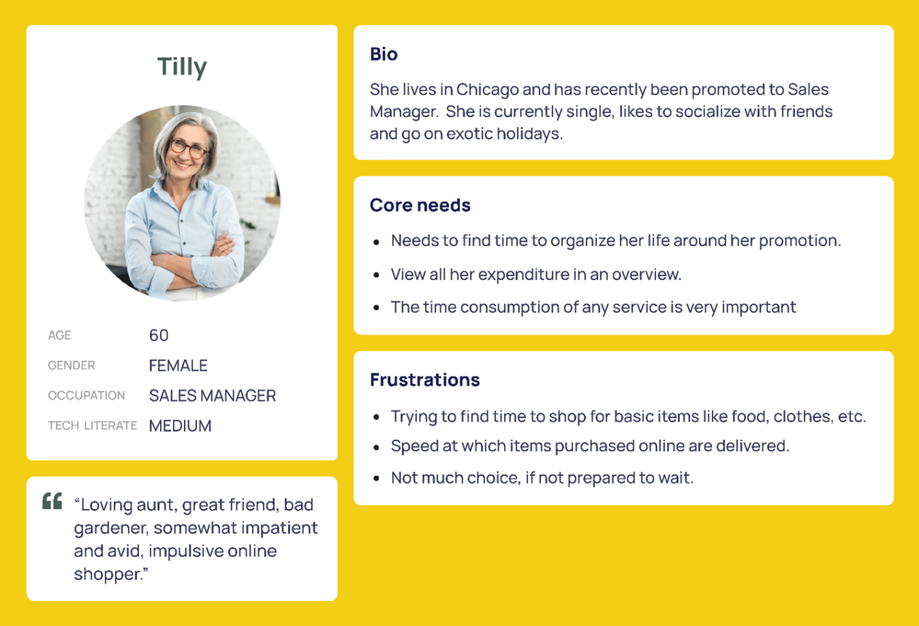

First, add a header to your persona; this includes a fictional name, an image, a demographic profile and a quote that summarizes what matters most to your persona. These features ensure your persona is memorable and helps the design team focus on whom they're designing for. Add a personal background, a mini-biography of sorts. Then you create a psychological profile such as the user's needs, interests, motivations, and pain points.

This allows you to understand better why your user behaves in a certain way, including why they need or want to use your product. For Tilly, in the above example, it would be for expediency. When creating user personas, remember to focus on the context of the product you're designing while you want to build up a realistic character. There's no need to include pointless details that won't influence the final design.

**User stories**

A user story is a brief statement or abstract that describes the user and their need or goal. It establishes who the user is, what they require, and why they require it. Each user persona typically has one user story. User stories usually adhere to a straightforward template:

As a (*type of user*), I want (*a goal*) for (*some reason*).

* Typeof *user:* This is the end-user or the user's role in the application software. For example: "*As an online banking customer.*"
* A *goal*: This is the action taken by the user on the application software. For example: "*I want to add a payee to my account.*"
* Some *reason*: - The outcome or desired value the user expects from the action performed. For example: "*so that I can transfer money to the payee."*

 In this example, the user story is:

 "As *an online banking customer*, I want to *add a payee to my account*, so I can *transfer money to the payee*."

User stories assist in documenting helpful information about users, such as the various needs and motivations for using a website or app. They also help the development team estimate the timeline required to deliver the final product.

**Scenarios**

A scenario is a situation that depicts how users interact with your website or app. Scenarios describe the user's motivations for being there (their task or goal) and a question they need to be answered. They also suggest possible ways to achieve these goals. Scenarios are essentially an extension of the user story and can be applied to various target users. However, they can also be divided into use cases, which describe the sequence of tasks that any given user performs in a provided functionality or path.

For example, a scenario could describe how the user transfers money to a payee using a mobile device on his way to work. Scenarios help stakeholders visualize the design team's ideas by providing context for the intended user experience — frequently bridging communication gaps between creative and business thinking. Scenarios aid the design team in imagining the ideal solution to a user's problem.

Scenario mapping is the first step in scenario planning. The design team, developers, and product owners gather to discuss ideas and design a plan centered on their user personas. They think about the critical task that the user hopes to achieve after defining the primary user through persona development. The following step is to conduct a scenario analysis, contextualize the user's goals and walk through the steps the user would take.

**Storyboards**

A storyboard is a visual representation of how a user will interact with a product. Designers can create different storyboards: sketches, illustrations and screenshots, slideshows and animations, or live demos. Here's a sketched storyboard example:

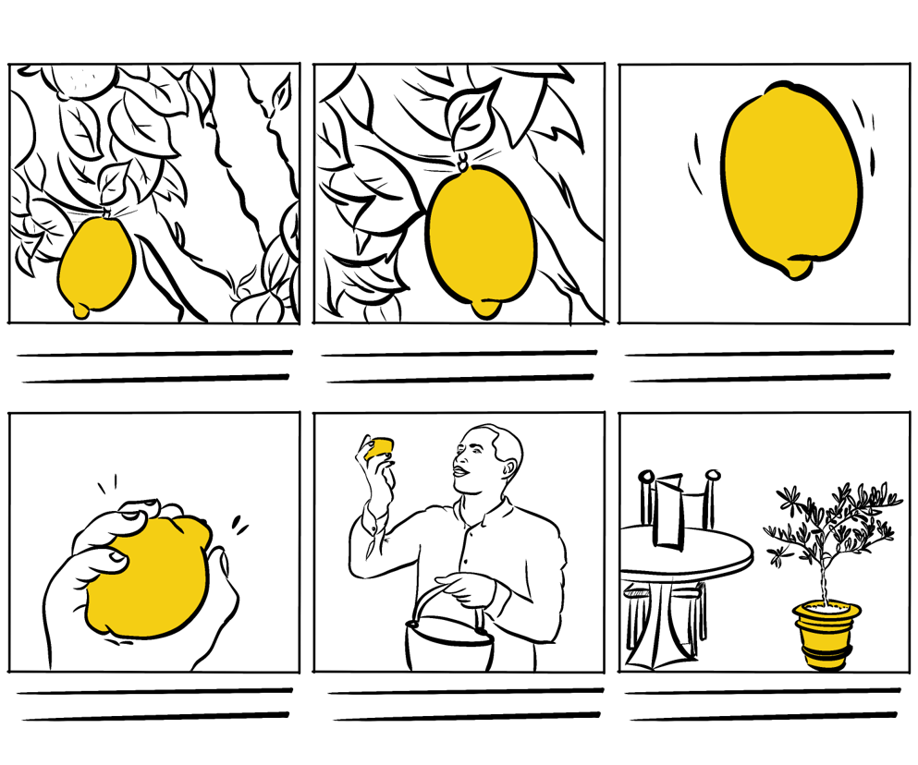

Storyboarding is an excellent method for visually communicating design concepts to teams, stakeholders, and end users. Visualizing a design idea with an interactive storyboard, like high-fidelity prototypes closely resembling the final product, will help the audience remember, empathize, and connect with it.

**How to create a storyboard**

To create a storyboard, set the scene by defining:

* your persona,
* the environment (where the persona is) and
* the plot (what they want to achieve).

Then you begin to sketch out the basic idea for each scene and build it up with as many interactions as you want.

**Summary**

In this reading, you learned that the first step in designing for your users is to conduct user research, typically through user interviews, observations and other quantitative methods. You focused on empathy tools as artifacts in the UX process and how they are used. You specifically learned about user personas, scenarios, user stories, and storyboards. Remember that with each of these tools, it is essential to document the data you gather so you can use it as you create your artifacts in the UX process. It will also serve to back up your decision-making. Utilizing user personas, user stories, scenarios, and storyboards will assist you in identifying essential information about your users. They will help you create products that will delight them time and again. Everything you do to get closer to the user is a positive step towards a usable and enjoyable product.

# Evaluation cheat sheets

You have previously learned about popular UX and UI evaluation methodologies and how and where these can be applied to improve your designs. Let's explore them in greater detail.

## Dieter Ram's 10 Principles of Good Design

### Good design is innovative

Whether you are making a change or doing something in a new way, developing new ideas or making improvements to existing designs and working alongside new technology, all of these offer a multitude of opportunities for you to be innovative within a design.

### Good design makes a product useful

It doesn't matter how stunning a product looks if it is practically unusable as it becomes completely worthless. Products are not pieces of art to be admired. They are there to serve a purpose and solve a problem.

### Good design is aesthetic

Beautiful items tend to make us feel comfortable. If a product is beautiful, you may be more inclined to use and want it. Some may argue against this point as you may have your own subjective idea of what is beautiful, and some well-designed items do prioritize utility over beauty. Regardless of your taste, you may like the things around you to be beautiful irrespective of how you define beauty.

### Good design makes a product understandable

For example, handles on doors that don't indicate if they should be pushed or pulled or taps that don't indicate if they are hot or cold just leave the user confused. The opposite of this is an instantly understandable product that is completely self-explanatory and communicates what it's about, what it's for and how to use it. This saves a user from breaking the product or spending time reading through instruction manuals.

### Good design is unobtrusive

An obtrusive product is an over-designed product. Products that tend to fail are those created with the designer in mind or with presumptions of who the user might be and or how they might use it. The very best products allow the user to do exactly what they want to do. These products should also help the user to complete their intended tasks effectively and happily. The design should not hinder the individual's intuitive process.

### Good design is honest

Good design doesn't have tricks! It doesn't pretend to be something that it isn't, and it doesn't try to manipulate you into buying it by making promises that can't be kept. It should always have the user's best interests in mind, so it shouldn't have to try to lie to you or try to be something that it isn't.

### Good design is long-lasting

Design should always be thorough to the last detail and avoids being fashionable which means that it never appears old or antiquated.

### Good design is thorough down to the last detail

A Good design should be detail-oriented and leave nothing to chance. Every single aspect of the design should be considered, and all the elements should qualify to be a part of that design. Products should be designed with care, thoroughness, and concern for the intended user.

### Good design is environmentally friendly

Pollution can arise from wasted resources throughout a product's lifespan. Design shouldn't be wasteful and should save resources where it can, both physically and digitally.

### Good design is as little as possible

Design should always be intentional. Anything that doesn't serve a purpose for the user should be excluded. With less clutter, a design will achieve more clarity for the user.

## Jakob Nielsen's Heuristics: 10 Usability Principles to Improve UI Design

### Visibility of system status

Explore your smartphone. Right after the screen lights up, it informs you about its battery and if you have a Wi-Fi connection, any received messages, missed calls and much more. Imagine how insecure you would feel if this information were missing. The system communicates its status and assists users in making better, more informed decisions by using signs, icons and indicators.

### Match between the system and the real world

Users may make assumptions about how a system will work based on their previous experiences with similar systems. You can help them overcome their initial discomfort by using language they are familiar with.

### User control and freedom

Digital spaces, like physical spaces, require quick 'emergency exits'. Users frequently select system functions by accident and need a clearly marked way to leave the unwanted position without going through an extended dialogue. So, support the undo and redo functions.

### Consistency and standards

Consistency is the key. A 'submit' button on one page should look the same across the site on any page. If you show information in a particular format on one page, it should look the same on all pages.

### Error prevention

A careful design that prevents a problem from occurring in the first place is even better than good error messages. Remove conditions that may cause errors in your design, or look for them and give your users a confirmation option so that they can make an informed decision before tapping or selecting anything.

### Recognition rather than recall

Allow your users to recognize information in the user interface rather than expecting them to remember or recall it. Simply put, don't make your users work any harder than necessary! Make your navigation as clear, detailed and straightforward as possible. Offer them hints, remind them when something time-sensitive needs to be done and notify them when a screen or a process has been changed.

### Flexibility and efficiency of use

Simply put, your system must be designed so that both experienced and inexperienced users can use it. Think of designing a system where a new user can find a way to perform a task without knowing any shortcuts. However, also design your system in such a way that an experienced user can use shortcuts to complete the action quickly and efficiently.

### Aesthetic and minimalistic design

Make a fantastic first impression! Users notice aesthetics or how visually appealing your system is in the first 50 milliseconds of landing on a page, which is ten times faster than it takes them to read it. This means that you should make sure that you establish and reinforce your system's brand identity and credibility.

### Help users recognize, diagnose and recover from errors

A good error message should be polite, easy to understand, precise, constructive, clearly visible, and take as little time as possible to fix the problem as well as educate your users.

### Help and documentation

Even though it is preferable that your system can be used without documentation. It is important that any such information should be: easy to find, focused on the user's task, include the actual steps they should take, and not be too large.

## Ben Shneidermann's 8 Golden Rules of Interface Design

### Strive for consistency

Consistency is critical to maintaining uniformity throughout the site, whether it's the layout, the size of the button, the color code, or the tone used when writing the page. Consistency will enable you to establish your identity and stop users from abandoning your site.

### Enable frequent users to use shortcuts

Think about allowing your users to access all areas of your website with a few clicks. To accomplish this, you should create a good hierarchy in the menu and make things clear. Consider including features for both advanced and novice users, such as keyboard shortcuts or macro-capabilities.

### Offer informative feedback

If your users have completed or are completing activities on your website, it is best to provide feedback as soon as possible so that they can understand where they are in the system.

### Design dialog to yield closure

All interactions must have a beginning, middle and end. Once a task is completed, maybe give your users some peace of mind by providing them with informative feedback and well-defined choices for the next step, if applicable. Don't keep them guessing!

### Offer simple error handling

An interface should be designed to eliminate as many errors as possible. If something goes wrong, the system should make it simple for users to understand and resolve the problem. A good idea is to display clear error notifications and descriptive hints to resolve the problem. These are examples of simple ways to deal with system errors.

### Permit easy reversal of actions

Finding that there is an "undo" option after making a mistake is a huge relief. Your users should feel less anxious and more likely to explore options if they know there is a simple way to undo any mistakes. This rule applies to any action, sequence of steps or data entry in your system. This can range from a single button to a complete set of actions.

### Support internal locus of control

It is essential to give your users control and freedom so that they feel in control of the system instead of the other way around. As the designer, try to avoid surprises, interruptions and anything that the users didn't request. Users should be the ones who initiate actions.

### Reduce short-term memory load

As users, our attention span may be limited, so anything you can do to make your users' jobs easier is a win-win situation. Your users may prefer to recognize information rather than recall it. Try to keep interfaces simple and consistent and keep to patterns, standards and conventions. This may contribute to better recognition and ease of use. Depending on your users' objectives, you can add various features to help them. In an e-commerce setting, for example, a list of recently viewed or purchased items can be presented.

## Final thoughts

While heuristic-based decisions can be taken lightly, adhering to a set of rules and guidelines helps to point you in the right direction and allow you to identify significant usability issues early in the design process. These guidelines apply to most user interfaces. You can take inspiration from these examples to develop your own set of heuristics, or you can combine them to solve your own design problems.

# Usability test cheat sheet and template

# Usability testing

Usability testing is an evaluative user research technique that allows key stakeholders and the project team to understand better how people interact with a product. Usability testing can be done during the design, development, or after the product has been released. During a usability test, participants are required to perform specific tasks with the product and provide feedback.

Usability testing research methods can be conducted remotely or in person. The types are as follows:

* User interviews
* Unmoderated usability testing

## User interviews

It is critical to ask the right questions during a User Interview. You get what you ask for, as the saying goes! Because the researcher's time during an interview is limited and there is usually so much to cover, asking all possible questions is not an option. So, knowing which questions to ask and which to avoid is just as important as knowing how to ask them.

### Prior to the User Interview

This is the stage when all of the research preparations are made. The following deliverables are produced as part of this phase:

* Discussion Guide - research questions are prepared here, though what you write may not always be what you ask during interviews.
* Interview Schedule
* Roles and responsibilities, for example, notetakers, moderators, translators, and so on.
* Scenarios List
* A list of test materials, if any, are required, such as design prototypes, competition websites, and so on.
* Reliance on stakeholders
* Forms of consent and disclosure, etc.
* Exit survey, which is mostly closed-ended questions

### During the User Interview cycle

Whether the interviews are for exploratory or evaluative research, the ability to ask the right questions is crucial here. Let's explore some examples of how to run an effective interview.

#### Different types of questions

i) Warm-up question –it is important to get the participant talking and comfortable. For example, you can start by asking, "Do you prefer coffee or tea?"

ii) Begin the investigation with open questions.

* Explain your experience
* How many/how much...
* What is the cause of...
* When was the last time you...
* How do you...

iii) Task-based questions

* Show us how you do it...
* What motivates you to do that...
* What preparations do you need to make...

iv) Recall a previous experience

* Could you please share your most recent experience with...
* Tell me everything you remember about the last time you used...
* What was the most noteworthy aspect of...
* Consider a real-life situation in which this could have been useful...

v) Beliefs and attitudes

* What are your thoughts on...
* What do you enjoy the most about...
* What do you despise the most...
* In what way could this be useful...
* If you were to consider the advantages of... what would they be...
* What are your thoughts on...

vi) Inquiry questions

* Please tell me more about that.
* Could you please elaborate?
* Why did you go about it that way...
* Why did you think that...
* Let me repeat what you said. Is this what you meant?
* What makes you think that...
* If you think about it again...

vii) Closing remarks

* Do you have any questions you'd like to ask...
* Is there anything else you'd like to say?

### After the User Interview

After you conduct user interviews, it is time to review the data you collected to use it in your design. Debriefing and topline summary are important items in this step.

#### Debriefing

Debriefing aids in determining what went well during the session. What can be improved, prioritized and so on.

#### Preparation and distribution of topline summary

This keeps stakeholders up to date on current findings and aids in making initial project and product decisions.

#### Updating the Research Schedule

This step deals with dropouts, changes in participant availability and so on. Stakeholders will always have questions that will be triggered during the interview. As a result, a researcher acting as a moderator should be on the lookout for those questions and try to incorporate them into the interview if time allows. Try to be as broad as possible with open questions. And remember that there is always more than you can say.

## Unmoderated Usability Testing Types

With regard to its relationship to usability testing, the term "unmoderated" refers to research participants using the product when no one is watching or interacting with them. Unmoderated usability testing can be done in two ways:

### Unmoderated in-person usability testing

The product is used by the participants at a predetermined physical location. No one is watching the participants while they use the product. After the user session is finished, the researcher may record and investigate the interaction and any comments made during the product usage. This method of usability testing is less popular than remote unmoderated usability testing because it requires the presence of researchers and participants at a fixed time and location.

### Unmoderated remote usability testing

This method employs a user research platform based on the Internet. The participants and the researcher do not need to be in the same place at the same time to use this method. They could be anywhere in the world where an internet connection is available. The participants complete the tasks, and their interactions with the product are recorded and uploaded to a server. The researchers later on, in their own time, access the screen recordings of the interactions and interpret the feedback from the participants. This feedback may include face recording as well as verbal think-aloud comments.

### How to Conduct an Unmoderated Usability Test

To successfully conduct unmoderated remote usability testing, the following preparation is required:

1. Define the usability testing objectives.

* What do stakeholders want to learn?
* How would the findings benefit the company?
* Is the research method appropriate for all the objectives?
* Are all stakeholders in agreement regarding the goal statements?
* Which of the objectives can be included in future rounds of usability testing?

2. Determine the participant profile

* Number of targeted profiles and personas
* Age group, gender, nationality, and income of the target audience
* Relevant behavioral attributes, such as what they do, like, and dislike
* Sample size: the number of participants in each profile

3. Screen and shortlist candidates

* Prepare a list of screener questions to help you select your candidates.
* Determine which answers should qualify or disqualify candidates for participation.
* Level of comfort in thinking aloud
* Include a question to assess feedback articulation ability.
* Collect contact information to distribute the usability test and reach out if necessary.
* Request that participants consent to participate and agree to be recorded.
* Request consent from participants to store their personal information, if any.
* Include the type of incentive, the amount, and the payment method.

4. Choose a platform for user research

Choose a remote usability testing platform based on the information you want to collect and the products that participants will be testing.

* Is the platform compatible with the research method you will conduct?
* Is the platform capable of attracting participants?
* Is the platform capable of testing test material?
* Does the platform support the devices that the test must be run on, such as a computer or a mobile device?
* Is the platform video-centric?

5. Gather test materials

Determine and decide what you want the participants to test with the following options:

* Wireframes
* Design prototypes
* If necessary, the participants may need to sign a non-disclosure agreement.
* The availability of test materials as a dependency must be included in the usability testing plan.

## 

 6. Create a list of tasks to be completed as well as a list of usability metrics.

* Make a list of the tasks that the participants would be responsible for. Create the tasks based on what users would accomplish with the product.
* Limit yourself to 5 or 7 tasks at a time.
* Each task must correspond to the study's objectives.
* Tasks must be clearly worded and unambiguous.
* Clearly defined success criteria.
* Each task must specify an end state so that participants know the task has been completed.
* The sequence in which tasks are to be presented is referred to as task flow.
* Determine usability metrics for each task.

7. Determine usability metrics for each task.

* Failure or success
* Time to complete the task
* Time to first click or tap
* Count of clicks and taps
* Count of swipes
* Paths of navigation, such as the number of pages or screens
* A task's number of retries

8. Plan questions to be asked after the tasks are finished

Survey questions can be asked at the end of any task and immediately after completion. Survey questions can be of various types:

* Unanswered questions
* Single or multiple choice
* Likert scale of 5 to 7 points
* Dropdown
* Matrix or ranking
* Inquire about recall, task difficulty, and any additional information relevant to providing background information about participants, such as other similar experiences they have had.

  9. Perform a test run prior to the test launch.

* Experimenting with the test yourself, also known as a dry run, helps to refine it.
* Dry run with internal and external participants
* Determine whether or not there is a fatigue factor in completing the test.
* Check to see if everything is working as it should. For example, prototypes are loading correctly and are the correct ones.
* Fine-tune questions and include information that may have been overlooked.
* If everything is in order, start the test.

## Final thoughts

Now you know more about usability testing and the steps involved in two broad categories: user interviews and moderated and unmoderated user testing. Hopefully, you will be able to use what you learned when you carry on your design.